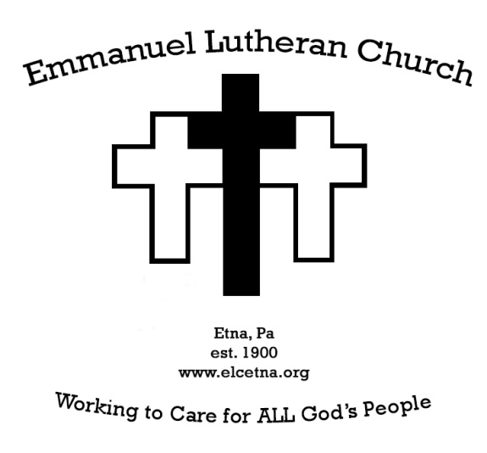

Weekly Announcements
January 16 and 23, 2022

PASTORAL CARE NEEDS When you, members of your family or friends in the congregation are to be hospitalized or are sick, please call the church office or Pastor J.J. at 412-600-6232.

Pastor JJ will be “away” occupied with continuing education classes on January 18, 19, 20, 25, 26, & 27. Pastor Chris Hough will be available for urgent pastoral care needs those days as well as preaching and presiding on Sunday January 23rd.

Celebration of the Resurrection and Life of Bob Anderson will be January 29, 2022 at 10am in the sanctuary at Emmanuel. All are welcome to attend to celebrate and commend to God our brother Bob who passed to peace eternal in December.

Dartball. We've called a timeout on Dartball. Please keep an eye on the announcements for when and if we call time in this season.

Annual Congregational Meeting January 30, 2022 after worship. At this time we are planning a brief in-person Annual Meeting to be held immediately after worship in the sanctuary.

Happy birthday to Rachel Coates. In honor of Rachel's 90th birthday, Kathy and Jim Suhadolnik invite you to a light luncheon in the fellowship hall on January 30, 2022 following the Annual Meeting.

Help needed in refreshing our spaces. The stage removal was so successful that we have new eyes to see what has reached the next stage of its journey in our spaces. Come and help on January 22 starting at 8:30am to help clean out our nooks and crannies.

Worship Volunteers needed Our current schedule is complete at the end of February. Now is the time to embrace a new method of serving. If you are interested in serving as a reader, communion assistant, greeter, or livestream operator, please be in touch with Pastor JJ. Current volunteers have done great work and are in need of more partners in our worship ministry. That means you have a place to serve! Please let Pastor JJ know which (or all) of these positions you want trained up in.

The Legacy of Dr. Martin Luther King Jr Sunday, January 16 @ 4 PM, Berkeley Hills Lutheran Church (517 Sangree Rd.) swpasynod.org/mlk2022
Our synod will be celebrating the legacy of Dr. King with an ecumenical service of Holy Communion; Bishop Abraham Allende will preside and the Rev. Lamont Wells will preach. The service will encourage membership of the synod and our partners to be engaged actively in the practice of nonviolence in our continuing efforts to build the Beloved Community in Pittsburgh. As allowed by COVID protocols, the service will be in person and live streamed. Masks are required for in person attendance

OUR CONCERN LIST
Greg Bauers, Carl Nicklas, Edna Zimmerman, Linda and Dave Farmerie; Carol Sherman, Gary Alberth Jr, Donna French, Dave Kobert, Doug Krachala, Shirley Simon, Bertha Trdina, Joan Fleishner, Grace Tyson (Char Ingold's mother), Susan Huffman, Earl Zinsser, Jerry Lynn, Carol Whiteside, Ed Kestner, Valerie Kestner and Dorothy Fischetti; Pastor James and Nancy Horn; Bill Coates, Jamie Fait, Gary Jurgis, Jeff Crabtree, Pat Powers, Donna Lewis, Rachel Coates;

Please keep our Bishop, Kurt Kusserow in your prayers as he is away on sabbatical. That this may be a time of rest, joy and rejuvenation to the ministry work God has called him to through us. And for Bishop Abraham Allende as he serves as our Acting Bishop in the meantime.

Those serving in the military: Rob Umbaugh, Larry Baumiller, III, Dalton Bailey, Pat Sharkey, Evan Stitch. [Please note: We ask the families and friends who have requested prayers to please give us a call when your loved one may be removed from our list.]

BULLETIN PRAYER REQUESTS
If you have a prayer request for the prayer chain, please contact Edna Zimmerman (412-487-354) or Rachel Coates (412-486-0830). You can also add names to the bulletin prayer list with fewer personal details during this time of pandemic by calling the office or sending an email to Pastor JJ. Thank you for your prayerful concern and care about our neighbors and friends!

Find Emmanuel on the Web at:
elcetna.org
Find Emmanuel on Facebook at:
Facebook.com/elcetna.org

Welcome the newly baptized!
December 26, 2021
Brigham Oskar Sundermann. Son of Hannah Smith and Alex Sundermann. Baptismal Sponsors Megan Egy and Joshua Sibbald.

December 29, 2021
Carly Haramic
Brooklyn Haramic
Tristan Haramic

Please keep our new siblings in Christ in your prayers as they walk their journeys of faith with our Lord Jesus and the whole church.

Altar or Credence Flowers
January 16 IMO Helen Spelic by Sue Spelic
January 23 IMO Marvin Parker by Linda and Leo Henne
January 30 In Honor of Rachel Coates’ 90th
birthday by her family
February 6 In Honor of Don and Edna
Zimmermans’ 60th wedding anniversary
February 13 In memory of Gerry French and
Marge Vidal by Donna French
February 20 NEEDED – See Edna Zimmerman if
interested in providing altar flowers this day
February 27 IMO Bob Simon and Larry Hiles by Shirley
Simon and family.

Bread of Life Food Pantry Etna Food Drive Donate for Covid-19 Relief
Drop off non-perishable food:
Monday 2-4 pm
Wednesday 6-8 pm
All Saints School Building - Dewey Street
(monetary donations will also be accepted)
Partners:
All Saints Catholic Church
Borough of Etna
Bread of Life Food Pantry
Etna Community Organization
Emmanuel Lutheran Church

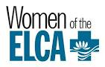
Attention Women of Emmanuel Lutheran Church

This is an open invitation to all confirmed girls and women of Emmanuel to join us for our in-person meetings on the second Thursday of the month, at 12:30 to 3:00 pm (note the time change). Please bring a bag lunch.
Our Meetings consist of a Bible Study, business meeting, with work on a project that will benefit the church and the surrounding community, and fellowship. Please make this year the year you plan to join Emmanuel’s WELCA. If you have questions or would like more information, please contact Edna Zimmerman.

Emmanuel’s Women of the ELCA continue to collect for Blessed Bundles through 2021. Items needed are: baby and toddler items such as wipes, diapers, blankets, undershirts and gently used clothing items. Also, could use bounders, swings, playpaks, etc. Toys are not needed at this time. You can bring the items to church and leave them in the containers available at the side entry to the sanctuary. Thank you all for your donations.

Northside Ministry Pleasant Valley Men’s Shelter Donation
Gently used men’s clothing is being collected for our ministry with the Pleasant Valley Men’s Shelter. Items can be left in the hallway between the sanctuary and Sunday School rooms.

OPTIONS FOR GIVING
→Offering plates are at the entrance to the sanctuary where the sign-in book is, as well as the exit in the Narthex
→Offering can be given through Tithely at https://tithe.ly/give?c=1046944
→For additional support of Emmanuel be sure to claim us as your Amazon Smile beneficiary by beginning your Amazon shopping at this unique link https://smile.amazon.com/ch/25-1267230

Emmanuel Capital Roof Project – 2021
The Church and Sunday school roof project was completed this year and if you would like to help offset the cost of the new roof, please place your contribution in a pew envelope and designate roof fund. Remember to include your name in order to have this entered on your contribution statement. Thank you.
Planned $80,000
Expenditures $71,864
Transferred From Reserved Funds
$51,864
Donations/Contributions $ 6023
Remaining Balance $14,776

Emmanuel’s Financial Status through December 2021

Budget $175,667
Spending $167,204
Offering Collected $158,167

Emmanuel's Current Congregational Councilpersons
Tom Hough, Vice-president
Jeanne Krachala, Secretary
Terry Tuite, Treasurer (appointed)
Danielle Barr Jack Dellert
Dean Ingold John Mertens
Fred Prefling Kevin Smith

Emmanuel Lutheran Church

Grant & Highland Avenues Pittsburgh, PA 15223
Church Phone: (412)781-2764
pastor@elcetna.org
secretary@elcetna.org

WELCOME VISITORS!
Welcome to Emmanuel Lutheran Church! We are glad that you are worshiping with us. If you have no church home in this community, why not make Emmanuel your own? Please sign the guest book in the narthex. If you are interested in becoming a member of the congregation, please talk with Pastor JJ. JJ can be reached by phone at 412-600-6232, or via email at pastor@elcetna.org.

OFFICE HOURS
The church office hours are irregular while our secretary is away. Please be in contact with Pastor JJ in the interim with administrative needs or questions.

